**PSK TECHNOLOGIES PVT. LTD.**

# Web Development & Training ,Sales & Services

**Office Address- Plot No.780 Tailors Line Near Durga Mata Temple Katol Road Chhaoni Nagpur-13**

# [www.psktechnologies.co.in](http://www.psktechnologies.co.in/) Contact No.9975288300 / 9970141466

**CCNA Content**

Paper 200-125

Routing & Switching

1. Internetworking
2. OSI & TCP/ IP and internet layer
3. Sub netting, Variable Length Subnet Mask (VLSM)
4. Introduction to CISCO Routers & Switches
5. Foundation CISCO IOS operations
6. Foundation CISCO Configuration
7. Introduction to routing & routing protocols
8. Distance vector routing protocols
9. Link State Protocol & Hybrid Protocol RIP , RIP V2, IGRP, EIGRP, OSPF
10. Layers 2 switching & spanning tree Protocol (STP) 11.Virtual Lan’s (VLAN)
11. Using CISCO access list
12. NAT ,PAT 14.Wireless technologies 15.Wide Area Network

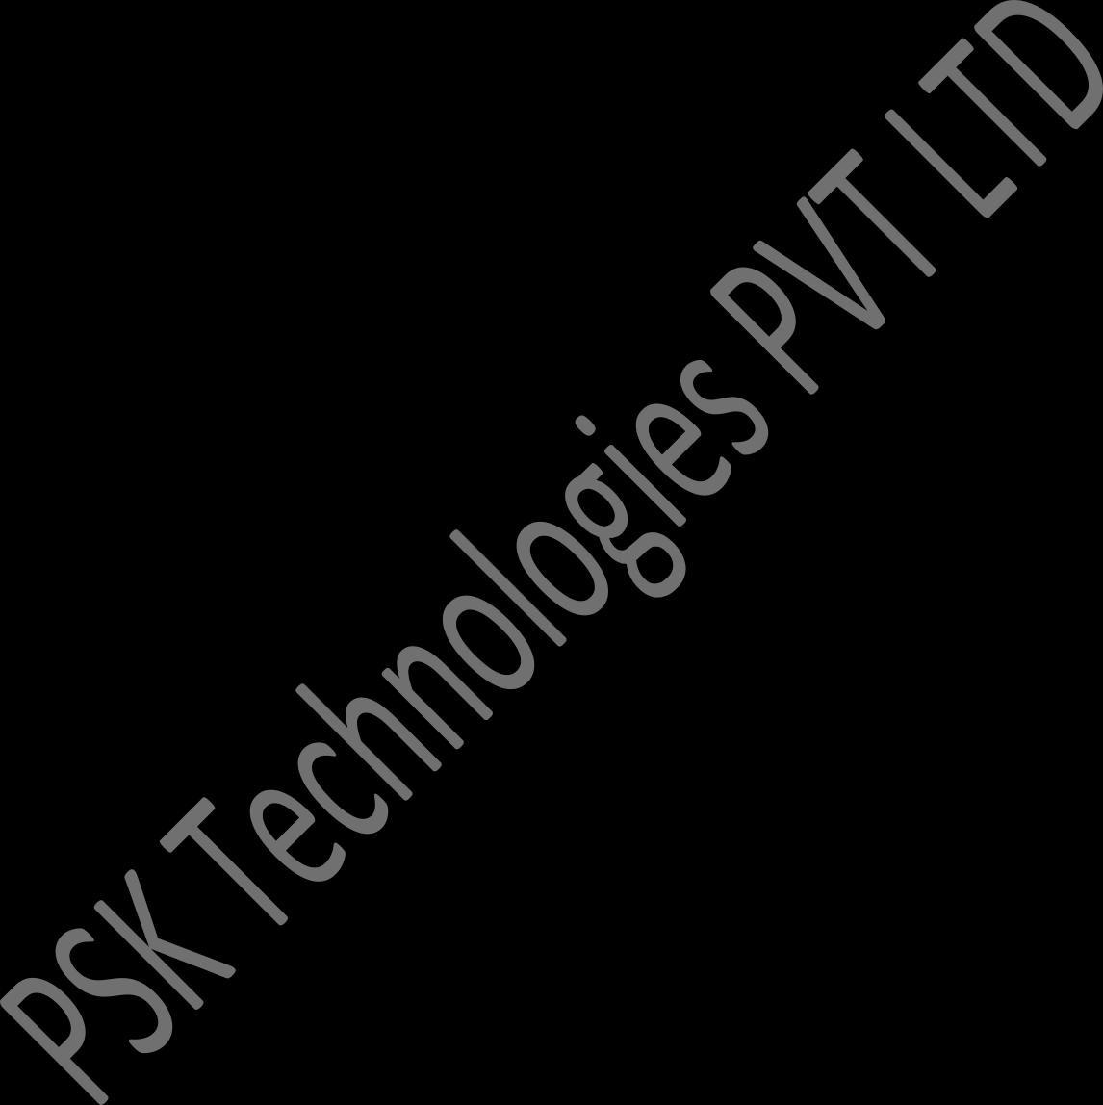16.Ip v6